WESTERN MONTANA AREA VI AGENCY ON AGING, INC.

COVID-19 COMMUNITY RESOURCE LIST
LAKE COUNTY: During such a trying time for our nation and state, it is more important than ever that Montanans help each other. Below is a list of your local organizations and resources that are here to help you during the COVID-19 outbreak. Many of these organizations can provide services remotely so you can access the help you need from home.
ARLEE – CHARLO – POLSON – RONAN – ST. IGNATIUS
__________________________________________________________________________ Health Care Facilities:
The listings below are for Lake County and are available to see patients, however, it is suggested to call ahead. Just click on the website for additional information.

- Polson Health
106 Ridgewater Dr Suite A
Polson, Montana 59860 Phone: (406) 883-3200
https://www.krh.org/krhc/contact-us

- Providence St. Joseph Medical Center
6 13th Ave East Polson, MT 59860
406-883-5680
Maps & Direction
- ST. Luke Community Healthcare
- Clinics: Ronan (406) 676-3600
St. Ignatius (406) 745-2781
Southshore (406) 883-2555
Ridgewater (406) 883-3737
- St Luke Hospital: (406) 676-4441
stlukehealthcare.org
ADDITIONAL INFORMATION:
- https://lakecountypublichealth.org/health-alert/
_________________________________________________________________________
Pharmacies:
If you are currently receiving your RX from Wal Mart, there is a new program. Wal Mart will ship your RX to you via Fed EX. Contact your local Wal Mart for details. Costco also has RX Mailing at no additional cost to members.

- Lake County Council on Aging and Transportation- 528 Main St SW Ronan 676-2367 Leave Message to arrange transportation for pickup of RX or other items.

- Polson: Providence St Joseph Pharmacy 6 13th Ave E 883-8444. Free delivery or mail. Patients please call if RX being picked up by another ID for controlled substances.
- Polson: Credena Health Pharmacy 50331 US Hwy 93 (Super 1) 883-0342 Free delivery or mail. Patients call ahead if RX picked up by another ID for controlled substances.
- Polson: Safeway Pharmacy 1146 South Shore Route 883-3674 Free mailing, and free delivery on T and F only within 10 mile radius.
- Polson: Walmart 36318 Memory Lane 883-9221 drive thru and store has 60+ Tuesdays 6-7 am
- Polson: Walgreens 40770 Mount Hwy 35 300-6042 Drive thru. Patient please call ahead if others picking up RX Tuesdays 8-9 am Seniors only All day Tuesday Seniors 20% off name brand and 30% off Walgreen brand.

- Ronan: Family Health Pharmacy 633307 US 93 676-2111 drive thru and curbside
- Ronan: R&R Health Care Solutions Pharmacy 63802 US Hwy 93 676-5600 will deliver within Ronan city limits, will mail, can do curbside if paid with CC in advance.

- ST. Ignatius: Mission Drug 110 N Main St 745-3000 Call ahead for curbside delivery Will mail except controlled substances and NO PO Boxes.

_______________________________________________________________________

Food / Groceries:
Many of the local establishments have set special times for seniors and individuals with disabilities to shop separately from the general public. Additionally, several locations have delivery and curbside pickup for your convenience.

- POLSON: Polson Senior Center –504 3rd Ave E 883-4735 Open and serving To-Go meals M-F 11:45-12:30 Call ahead for meals. Served curbside. Home Delivered program (Meals on Wheels continues- call for application)
- Mission Mountain Natural Foods – 319 Main St 883-2847 Regular store hours Call ahead for delivery availability. Will do curbside pickup and charge CC but must call and order ahead.
- Walmart Polson: https://www.walmart.com/store/2607/polson-mt
- Super 1 Foods Polson: https://www.super1foods.net/
- Safeway Polson: https://local.safeway.com/safeway/mt/polson/146

- RONAN: Mission Valley Senior Center, 528 Main St SW 676-2371 Open for grab and go meals M-W-F call ahead and leave message to be placed on meal schedule for following day.
- Boys and Girls Club: 62579 US 93 Ronan 676-5437 Follow them on Facebook
https://www.facebook.com/flatheadbgc/ For additional scheduling and updates
- Harvest Foods: 63802 US Hwy 93, 676-3301 No delivery or curbside. Senior Citizen hours T and Th 6-9 am
- Family Dollar Store: 9 Dayton St SW Ronan 552-0859 Patrons can call ahead and clerk will bring order out to vehicle where they can pay at the vehicle.

- ST IGNATIUS: St Ignatius Senior Center, 212 N Main 745-4462 leave message and call ahead to order meals. Take out and Home delivery only.
- Rod’s Harvest Foods: 116 N Main St St Ignatius 745-4275 Call ahead and clerk will deliver curbside where you can pay at that time.
- CHARLO: Charlo Grocery, 55609 Mount Hwy 212 Charlo 644-2575 Will do curbside delivery but must be paid with cash or check .

- ARLEE: Wilson Foods, 92345 US Hwy 93 Arlee 726-7777 Service remains same.
- http://www.polsonchamber.com/takeoutpolson/ (TAKE OUT ESTABLISHMENTS IN OUR AREA)

- Confederated Salish & Kootenai Tribes: Continue to provide essential services with Home Delivered Meals provided through the tribal nutritional sites below. For questions about Elder Services, please call Constance Morigeau at 675-2700, Ext. 1381.

- Arlee Tribal Nutrition Site 406-726-3221
- Elmo Tribal Nutrition Site 406-849-5022
- Polson Tribal Nutrition Center 406-883-6877
- Ronan Tribal Nutrition Center 406-676-5495
- St. Ignatius Tribal Nutrition Center 406-745-4240

Mental Health:
Mental Health Information
Montana 211 (information for a variety of services and volunteering opportunities)Dial 211 or752-8181
State Mental Health Services Bureau888-866-0328
Western Montana Mental Health Center532-9190
Addiction Treatment Help Line877-887-5016
Drug Abuse Hotline (24 hrs)800-311-3069
Alcoholics Anonymous888-607-2000
Montana Mental Health Ombudsman (help navigating system)888-444-9669

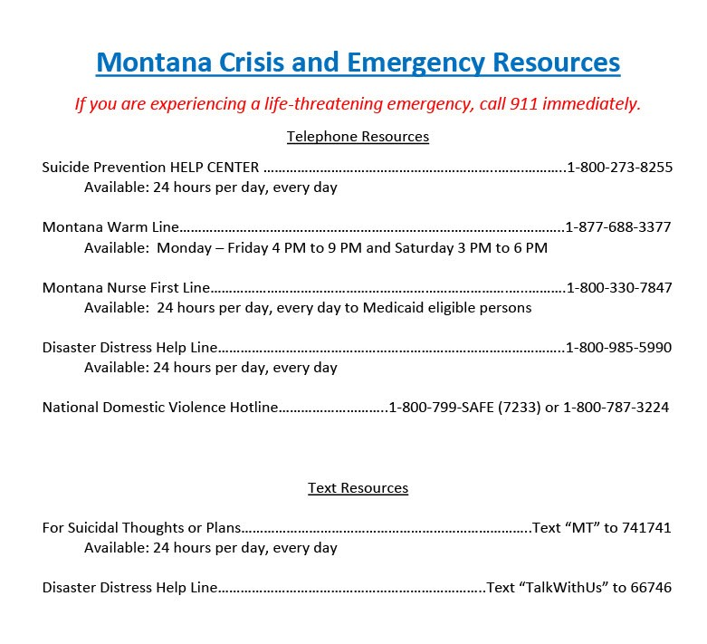

Other Resources:
Information and resources for the public from the multiple agencies and organizations responding to COVID-19 in your local communities and surrounding area. Many have special hours and are here to help during these uncertain times.

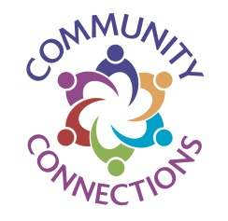

- https://lakecountypublichealth.org/health-alert/ (COVID 19)

- http://mdt.mt.gov/publictransit/missoula.shtml (Transportation)

- https://www.daines.senate.gov/coronavirus-resources/help-for-montana-seniors (Other resources in the area)

- Helping Hands: P O Box 1094 Polson Jennifer 883-8256 Every M & W will drop off groceries, medication call by previous Friday.
- New Life Church: www.newlifepolson.com 1414 2nd St W 883-2447 or call 304-7013 can assist with different tasks, call for more information.
- Hot Springs City Hall: 109 Main St 741-2353 Call for Community Information
- Shepherd of The Valley Lutheran Church: 1192 Mt. Silcox Dr Thompson Falls 827-9570 Contacts: Pastor Jacob Berger, Mark and Karen Sheets, Congregation. They are willing to volunteer, and availability will depend on request.
- http://www.polsonchamber.com (Polson Chamber of Commerce)

