WESTERN MONTANA AREA VI AGENCY ON AGING, INC.

COVID-19 COMMUNITY RESOURCE LIST
LINCOLN COUNTY: During such a trying time for our nation and state, it is more important than ever that Montanans help each other. Below is a list of your local organizations and resources that are here to help you during the COVID-19 outbreak. Many of these organizations can provide services remotely so you can access the help you need from home.
EUREKA - LIBBY - TROY
__________________________________________________________________________ Health Care Facilities:
The listings below are for Lincoln County and are available to see patients, however, it is suggested to call ahead. Please call the phone number listed for driving directions and additional information.

- Eureka Health Care / North Valley Hospital
304 Osloski Rd
Eureka, MT
406-297-3145
If you think you have been exposed to COVID 19 call first for an evaluation

- Cabinet Peaks Medical Center
209 Health Park Dr.
Libby, MT
406-283-7000
http://www.cabinetpeaks.org/

- Lincoln County Public Health Dept:
http://www.lincolncountymt.us/public-health/immunizations/clinics

ADDITIONAL INFORMATION:
- https://lccovid19.blogspot.com/ (LINCOLN COUNTY COVID19 SITE)

__________________________________________________________________
Pharmacies:
If you are currently receiving your RX from Wal Mart, there is a new program. Wal Mart will ship your RX to you via Fed EX. Contact your local Wal Mart for details. Costco has RX Mailing at no cost to members.
- Libby: Rosaures Pharmacy- 703 W 9th 293-2743 Drive Thru Pickup
Special shopping hours for seniors 7 days a week 7-9 am
- Libby: Granite Pharmacy- 1404 Minnesota Ave - 293-3784 Drive Thru Pickup. Delivery on individual basis.
- Libby: NWCHC Pharmacy- 320 E 2nd 283-6900 Curbside pickup & Delivery
- Troy: Kootenai Drug – 611 E Missoula Ave- 295-4361 Call ahead for curbside pickup also available delivery on a limited basis.
- Eureka: Eureka Drug- 546 US Hwy 93 N- 297-7748 Drive thru Pickup and Police deliver meds when needed.
________________________________________________________________
Food / Groceries:
Many of the local establishments have set special times for seniors and individuals with disabilities to shop separately from the general public. Additionally, several locations have delivery and curbside pickup for your convenience.

- EUREKA: Tobacco Valley Senior Center –301 1st Ave E Please Call Ahead 297-2188 Take out only: Meals delivered M-Hot Meal, T-W-F Sack Meal, and TH Frozen Meal.
- Commodities: 520 Dewey Ave #2- 297-7729 Must Apply- Pickup & Delivery
- Mt Market: 400 Dewey Ave- 297-2113 Limited delivery call for schedule & area
- Steins Market: Hwy 93 N Eureka 297-3151
- Fire & Slice Pizza: Hwy93 N Eureka 297-7795 Delivery & Pickup available
- Valley Pizza: 700 Hwy 93 N Eureka 297-2709 Curb side pickup
- Von’s Café: 601 3rd Ave East 297-2333 Curb side pickup
- Route 93: 5 Front St 297-7576 Delivery and pickup available
- On The Fly: 10555 Hwy 9S Fortine 471-8282 Drive up widow. Also on Facebook

- LIBBY: Libby Senior Center, 206 E 2nd 293-7222 Call ahead for meals. Open for Curb side pickup meals T-W-F and Home Delivery.
- Libby Commodities: 114 W 2nd ST 293-7316 Must Apply Call for application.
- Venture Inn: 1015 9th Ave 293-7711 Curbside pickup only or Libby cab delivers
- The Pastime: 216 Mineral Ave293-6097 Curbside pickup or Libby cab delivers
- McDonalds: 905 Louisiana Ave 293-4085 Drive thru Open-Only
- Pizza Hut: 903 California Ave 293-7744 Drive thru & Regular delivery hours

- TROY: Kootenai Senior Center, 304 3rd St Troy, 295-4140 Curb side pickup only. M- F Hot Lunch Please call the day before. Some home delivery available.
- Troy Food Pantry & Commodities: 725 E Missoula Ave 295-4206 Cam or Kathy Call for application Montana Food Bank open 2nd and 4th Thursdays of month.
- Troy Food Pantry: 301 E Kootenai Ave Glenda or Dave – Mon-10:30-Noon
- Steins Market: 607 E Missoula Ave 295-4177 Call Ahead for Curbside pickup and payment at curb or over phone on individual basis.
- R-Place: 616 E Missoula Ave 295-5028 Drive thru Only M-Sat Closed Sun.

Mental Health:
Mental Health Information
Montana 211 (information for a variety of services and volunteering opportunities)Dial 211 or752-8181
State Mental Health Services Bureau888-866-0328
Western Montana Mental Health Center532-9190
Addiction Treatment Help Line877-887-5016
Drug Abuse Hotline (24 hrs)800-311-3069
Alcoholics Anonymous888-607-2000
Montana Mental Health Ombudsman (help navigating system)888-444-9669

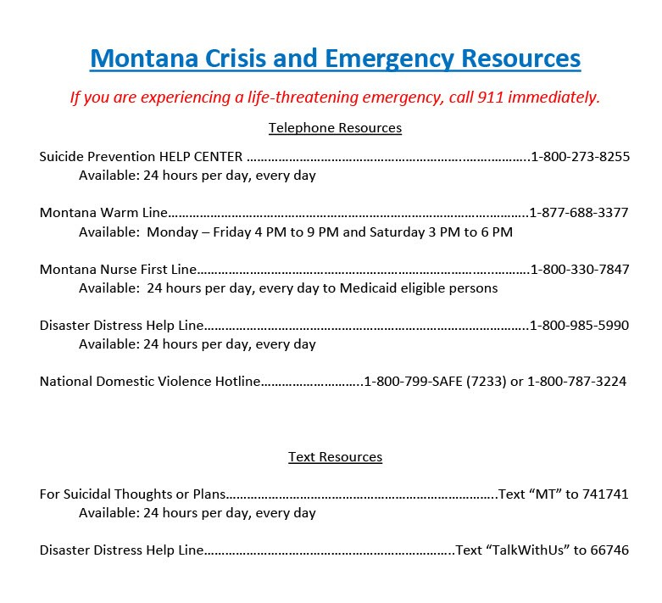

Other Resources:
Information and resources for the public from the multiple agencies and organizations responding to COVID-19 in your local communities and surrounding area. Many have special hours and are here to help during these uncertain times.

- https://lccovid19.blogspot.com/ (COVID19)

- http://mdt.mt.gov/publictransit/missoula.shtml (Transportation)

- https://www.daines.senate.gov/coronavirus-resources/help-for-montana-seniors (Other resources in the area)

- Western MT Area VI Agency on Aging: Tobacco Senior Center @ 301 1st Ave E Brenda Turnbull 291-5767 Assist with Medicare/Medicaid/MSP/LIS/LIEP Source for Information and Assistance. – By Phone only at this time.

- VFW-Eureka: 114 Dewey Ave Eureka - 293-1667 VFW & Telehealth CLOSED – Call Rick Weldon and they will help out anyway they can.

- Libby Cab Company: 406-334-9494 we come to you - Pickup & deliver for you.
- Libby County Transportation: 293-8024 running for medical necessities only.

- Libby-Methodist Church: 713 Main St 293-4522 or 295-4019 (Francine) Can distribute Basic Needs -Call for distribution times.
- Libby-Christian Church: 100 Kootenai River Rd 293-3747 Mrs. Erickson - Call for information on misc. resources available.
- Libby- Families in Partnership – Senior Care Program: 83 Collins Ave 293-6242 Please call – Senior Care packages available.

