WESTERN MONTANA AREA VI AGENCY ON AGING, INC.

COVID-19 COMMUNITY RESOURCE LIST
MINERAL COUNTY: During such a trying time for our nation and state, it is more important than ever that Montanans help each other. Below is a list of your local organizations and resources that are here to help you during the COVID-19 outbreak. Many of these organizations can provide services remotely so you can access the help you need from home.
ALBERTON - DEBORGIA - HAUGAN - SALTESE - ST.REGIS - SUPERIOR
__________________________________________________________________________ Health Care Facilities:
The listings below are for Mineral County and are available to see patients, however, it is suggested to call ahead. Just click on the phone number or map and driving directions to be directed to the location of your choice.

- https://mineralcommunityhospital.com (Hospital Clinic in Superior)

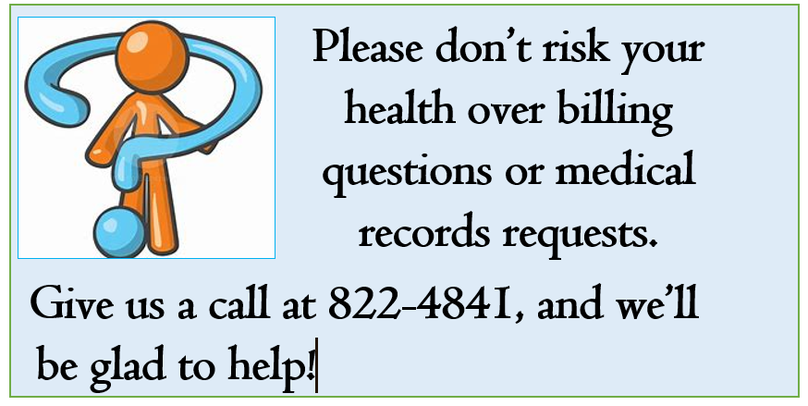
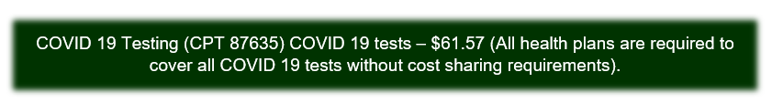

ADDITIONAL INFORMATION:
- https://co.mineral.mt.us/departments/health-department/

___________________________________________________________________________
Pharmacies:
If you are currently receiving your RX from Wal Mart, there is a new program. Wal Mart will ship your RX to you via Fed EX. Contact your local Wal Mart for details. Costco also has RX Mailing at no additional cost to members.

- Mineral Pharmacy: 207 River St, Superior 822-4681, M-F 9am-6pm Lobby closed please call ahead will do curbside pickup. Also, will do local delivery.

- Mineral County Pioneer Council: 239-4682 can arrange transportation for RX pickup.
_____________________________________________________________________________
Food / Groceries:
Many of the local establishments have set special times for seniors and individuals with disabilities to shop separately from the general public. Additionally, several locations have delivery and curbside pickup for your convenience.

- All Senior Centers by donation: $5.00 or $6.00 or $7.00 appreciated.

- ALBERTON: Alberton Senior Center - 701 Railroad 722-3372
Delivery and take out T- Th 12:00 -12:30. Please call the center between 9:00-11:00 to reserve the number of meals you would like to pick up. There is limited delivery and some people have been kind enough to deliver meals for their neighbors.

- Valley Grocery Store: 406 Railroad Ave 722-4946 Open M- Sat 9-7
and Sun 10- 5 - Has curb side service.
- Alberton Community Food Pantry: 502 5th St Open on the Second and Fourth Wed Call the Alberton Town Office for emergency availability and Days and Hours of Operation.
- Trax Bar: 516 Railroad Ave 722-4516 Open for take-out food, pizza, and
beverages, Monday - Sunday 12:00 - 8:00.

- SUPERIOR: Superior Senior Center - 611 5th Ave E1- 822-3334 Center is open to grab and go meals. Please call ahead for meal count. Pull up and honk for pickup of curbside meal.

- Durango's Restaurant: 202 4th Ave E 822-4967 Only take out and are open on M-F from 9:00-1:30 and 4:30-8:00 and Sat-Sun 9:00-7:00.
- Whipped Up: 100 River St 272-5874 Has take-out orders and based on staff availability, will deliver. Hours are Sun and M 8-3 Closed Tuesday.
Open Wed and Th 8-3. Friday and Saturday 8:00-8:00.
- Four Aces Bar: 20 Mullan Rd E 822-3273 Open for take-out, M -Sun 11-9
- Darlow's Quality Foods (Castles): 301 River St 822-4801Open regular
hours, Mon- Sat 7:00 a.m. to 9:00 p.m., Sun 8:00-6:00. No delivery.
- Food Bank- Superior: Contact Marlene Adair 308 Pine 822-3471 Open Fridays 10:00-12:00 and 1:00-3:00.

- ST. REGIS: St Regis Senior Citizens Center- 209 Lobo Loop 649-4833
Take-out meals on Thursday at 5:30 - 6:00 p.m. and the 4th Monday
of the month, same times. Please call and reserve the number of meals you will be picking up between 12:00 - 4:00 p.m.
Transportation: If transportation is needed for any of these meals, please call the Mineral County Pioneer Council, 406-239-4682, and Lorie Phelps, our dispatcher and driver will schedule you according to availability of drivers for our vehicles.

- St Regis Travel Center: 55 Mullan Gulch Rd 649-2407 Gas Station and
- Convenience Store open 24/7. Huck's Grill - takeout orders, 7 am – 9 pm
- Jasper's Restaurant: 85 Mullan Gulch Rd 649-2473 Closed at this time.
- Frosties Drive Inn: Old Hwy 10 E 649-9753 Closed at this time.
- OK Café: 31 MT Hwy 135 649-2742 Closed at this time.
- Stang's Market: Highway 10 East 649-2414 M- Sun 10-6 Can do deliveries, call for availability.
- Hideout Restaurant: 245 I-90 Frontage Rd, Exit 18 DeBorgia, MT 678-0090 Carry out and curb side, Wed- Sun12:00-9:00. Can deliver from Saltese to Henderson, 10 mm - 22 mm, call for availability.
- Old Montana Bar and Restaurant: 174 Frontage Rd W, Exit 10 Saltese, 678-4144 Carry out only, Friday-Saturday-Sunday, 11:00 - 8:00
- Mangold's Store and Motel: Frontage Rd, Exit 10 678-4328 Open 8 - 8
Motel hours 24/7.

Mental Health:
Mental Health Information
Montana 211 (information for a variety of services and volunteering opportunities)Dial 211 or752-8181
State Mental Health Services Bureau888-866-0328
Western Montana Mental Health Center532-9190
Addiction Treatment Help Line877-887-5016
Drug Abuse Hotline (24 hrs)800-311-3069
Alcoholics Anonymous888-607-2000
Montana Mental Health Ombudsman (help navigating system)888-444-9669

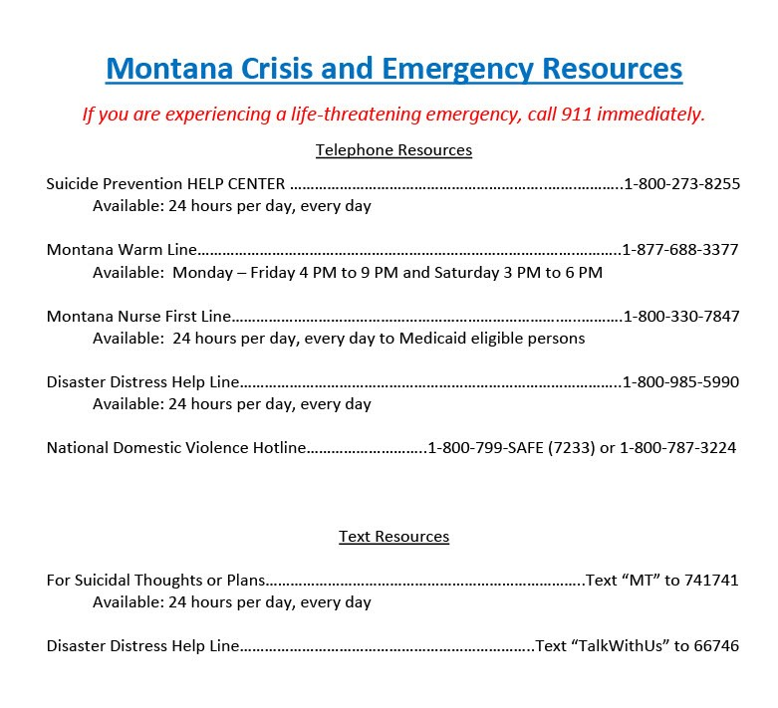

Other Resources:
Information and resources for the public from the multiple agencies and organizations responding to COVID-19 in your local communities and surrounding area. Many have special hours and are here to help during these uncertain times.

  - https://co.mineral.mt.us/departments/health-department/ (COVID19)

- https://www.daines.senate.gov/coronavirus-resources/help-for-montana-seniors (Other resources in the area)

- http://mdt.mt.gov/publictransit/missoula.shtml (Transportation in area)

- MINERAL COUNTY OFFICES:
Mineral County Health Department 406-822-3564
Mineral County Sheriff's Office 406-822-3555

- Alberton Town Offices 607 Railroad Ave Alberton, MT406-722-3404

- Super 8 Motel Old Hwy 10, Exit 33 St Regis, MT 649-2422 Open 24/7.

- Silver Dollar complex: I-90 Frontage Rd, Exit 16 Haugan, MT 678-4242 Silver Dollar Inn Motel is Open 24/7. Silver Dollar Convenience Store/Gas Station, Open 24/7
Silver Dollar Restaurant and Gift Store, Closed.

