WESTERN MONTANA AREA VI AGENCY ON AGING, INC.

COVID-19 COMMUNITY RESOURCE LIST
SANDERS COUNTY: During such a trying time for our nation and state, it is more important than ever that Montanans help each other. Below is a list of your local organizations and resources that are here to help you during the COVID-19 outbreak. Many of these organizations can provide services remotely so you can access the help you need from home.
HERON - HOT SPRINGS – PLAINS – NOXON- THOMPSON FALLS –TROUT CREEK
__________________________________________________________________________ Health Care Facilities:
The listings below are for Sanders County and are available to see patients, however, it is suggested to call ahead. Just click on the phone number or map and driving directions to be directed to the location of your choice.

- Plains Family Medicine
10 Kruger Road
Plains, Montana 59859
406.826.4810
Map and driving directions
- Thompson Falls Family Medicine
120 Pond St.
Thompson Falls, MT 59873
406.827.4442
Map and driving directions
- Hot Springs Family Medicine
209 Main St.
Hot Springs, MT 59845
406.741.3602
Map and driving directions
- Family Medicine Network Manager
406.826.4839

ADDITIONAL INFORMATION:
- https://co.sanders.mt.us/public-health-coronavirus-information/

____________________________________________________________________________
Pharmacies:
If you are currently receiving your RX from Wal Mart, there is a new program. Wal Mart will ship your RX to you via Fed EX. Contact your local Wal Mart for details. Costco also has RX Mailing at no additional cost to members.

- Sanders County Council on Aging and Transportation @ 203 Main St Hot Springs 741-2343. Open: M-TH 8-4 PM Leave Message to arrange transportation for pickup of RX or other items. Nutrition Program Plains/Paradise; Hot Springs, Thompson Falls, Heron, Trout Creek.
- Tribal Nutrition Center @ 214 Springs St N Hot Springs 741-3265 Call Deb King to arrange pharmacy pick up, and delivery to Hot Springs, Elmo, Lonepine, and Camas Prairie.
____________________________________________________________________________
Food / Groceries:
Many of the local establishments have set special times for seniors and individuals with disabilities to shop separately from the general public. Additionally, several locations have delivery and curbside pickup for your convenience.

- HERON: Heron Senior Center – Located at Heron Community Center
Please Call Ahead - 847-3737 Take out only: W – 5:30 – 6:00 PM
Recommended Donation: Children $4. Under 60 $7. Seniors $5.
- HOT SPRINGS: Hot Springs Senior Center – Main ST Hot Springs Please call ahead for service @ 741-2344. Providing meals on wheels and grab and go.
- Tribal Nutrition Center: 214 Springs St N Hot Springs – 741-3265 Deb King
Call M or W btw 9-2 or T-Th before 1100 to schedule a meal pickup.
MEALS: T and Th after 11:00 $3.00 recommended donation for 60+
- Food Pantry: 100 Main St Hot Springs 741-2012 or 242-0180, Joyce
Open Tuesday 10-1:30 Volunteers will fill order.
- Bucks Grocery: 223 Main St Hot Springs 741-2125 Open as follows:
M-W-TH 8-9 am Senior shoppers ONLY 9am -6pm all other customers
T-F & Sat (only these days) offering curbside and local delivery.

- Six Shooter Pizza: 510 Broadway St 741-3244 Delivery M-TH 11-7 & F 11-8

- Second Home Restaurant: 1962 Montana Hwy 28 741-5999 Open for Take- out and deliveries 7 days a week 11 am to 8 pm.
- Fergie’s Pub & Grill: 213 Main St 741-2416.Open for Take-out and deliveries 7 days a week 12 pm to 8 pm.
- Creekside Inn: 208 A St 741-5353 Open for Take-out

- PLAINS: Food Bank- Open Tuesdays 10 am to 1 pm Also a Soup Kitchen on Tuesdays for Take-Out from 11 am – 1 pm . Food is all to go and given out until they run out.

- NOXON: Noxon Senior Center 847-6000, Dinner served on Mon only 5-6 pm This is by Curb side pickup only and call ahead to order. $5 Seniors.

- THOMPSON FALLS: Thompson Falls Senior Center, 827-3457 leave message by 2pm same day to be placed on meal schedule for following day. Open for Grab and Go meals M-Th 5:45 -6:30 pm - Recommended donation: Seniors $5 and Under 60 $7.
- Two Rivers Grill & Catering: 105 Broad St - Call 827-2287 or Facebook Drive thru only M-F from 11am – 6pm.
- Big Eddy’s Deck Bar and Casino: 219 Main St W, 827-3300 call in orders or order online. Open: TH-Sat 4-7pm Curb side pickup only.
- Minnie’s Café: Main St 827-3747 Open 7 days a week 10 am – 3 pm Takeout

- TROUT CREEK: Trout Creek Senior Center, 18 Larch St 827-4461 leave message and call ahead to order meals. Take out only. T & F 4:30 – 5:50pm Starting 4-7-2020: may pick up lunch for Wed on Tuesday dinner pickup lunch for Sat on Friday dinner pickup if ordered ahead. Recommended Donation-Lunch: Senior $4 – Under 60 $6 – Child $3 Recommended Donation-Dinner: Senior $5 – Under 60 $7 – Child $4
- Trout Creek Wayside Bar & Grill: Hwy 200 Trout Creek 827-9996, Take out only. Order bulk food by 3pm Tuesdays can pickup on Thursdays. Offering takeout meals and alcohol. Open 7 days a week 12-8 pm

Mental Health:
Mental Health Information
Montana 211 (information for a variety of services and volunteering opportunities)Dial 211 or752-8181
State Mental Health Services Bureau888-866-0328
Western Montana Mental Health Center532-9190
Addiction Treatment Help Line877-887-5016
Drug Abuse Hotline (24 hrs)800-311-3069
Alcoholics Anonymous888-607-2000
Montana Mental Health Ombudsman (help navigating system)888-444-9669

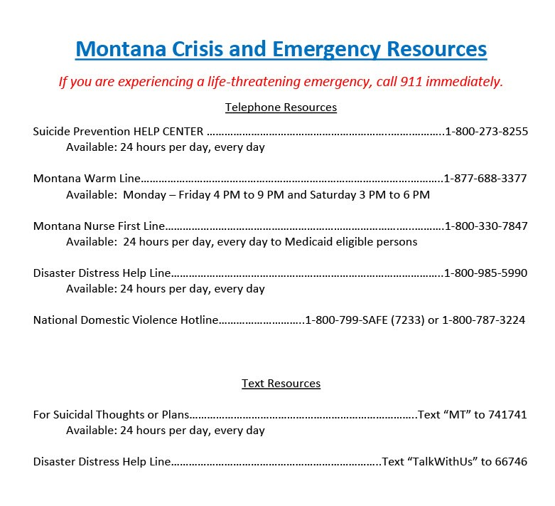

Other Resources:
Information and resources for the public from the multiple agencies and organizations responding to COVID-19 in your local communities and surrounding area. Many have special hours and are here to help during these uncertain times.

- https://co.sanders.mt.us/public-health-coronavirus-information (COVID19)

- http://mdt.mt.gov/publictransit/missoula.shtml (Transportation)

- https://www.daines.senate.gov/coronavirus-resources/help-for-montana-seniors (Other resources in the area)

- SANDERS COUNTY COUNCIL ON AGING AND TRANSPORTATION: 203 Main ST, Hot Springs 741-2343. Open M-TH 8-4 Please leave message Curb side only.
- Hot Springs City Hall: 109 Main St 741-2353 Call for Community Information
- Hot Springs Library Preston Town-County Library: 203 Main St E 741-3491 Books delivered upon request.
- Gambles (Hardware): 218 Main St 741-3345 Open M-Sat 10-3pm Provides curbside carry out and local delivery.
- Shepherd of The Valley Lutheran Church: 1192 Mt. Silcox Dr Thompson Falls 827-9570 Contacts: Pastor Jacob Berger, Mark and Karen Sheets, Congregation. They are willing to volunteer, and availability will depend on request.

